1. How many ConfigMaps exist in the environment?

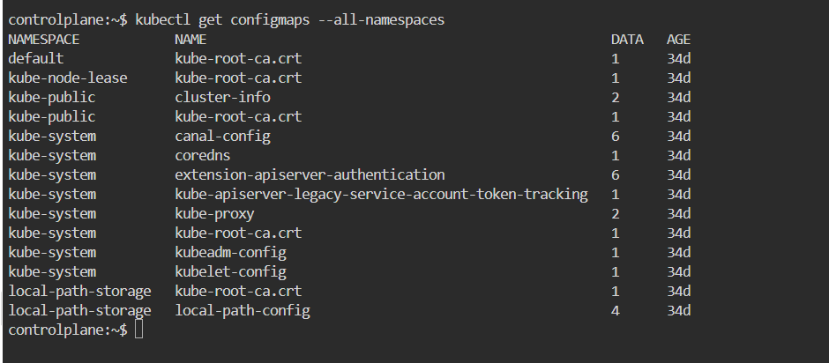

1. Create a new ConfigMap Use the spec given below.

ConfigName Name: webapp-config-map Data: APP_COLOR=darkblue





1. Create a webapp-color POD with nginx image and use the created ConfigMap



1. How many Secrets exist on the system?



1. How many secrets are defined in the default-token secret?



1. create a POD called db-pod with the image mysql:5.7 then check the POD status



1. why the db-pod status not ready

MySQL requires the MYSQL_ROOT_PASSWORD environment variable. Without it, the container fails to start, causing CrashLoopBackOff.

1. Create a new secret named db-secret with the data given below.

Secret Name: db-secret

Secret 1: MYSQL_DATABASE=sql01

Secret 2: MYSQL_USER=user1

Secret3: MYSQL_PASSWORD=password

Secret 4: MYSQL_ROOT_PASSWORD=password123



1. Configure db-pod to load environment variables from the newly created secret.

Delete and recreate the pod if required.



1. Create a multi-container pod with 2 containers. Name: yellow

Container 1 Name: lemon Container 1 Image: busybox Container 2 Name: gold Container 2 Image: redis



1. Create a pod red with redis image and use an initContainer that uses the busybox image and sleeps for 20 seconds



1. Create a pod named print-envars-greeting.
   1. Configure spec as, the container name should be

print-env-container and use bash image.

* 1. Create three environment variables:
     1. GREETING and its value should be “Welcome to”
     2. COMPANY and its value should be “DevOps”
     3. GROUP and its value should be “Industries”

1. Use command to echo ["$(GREETING) $(COMPANY) $(GROUP)"]

message.

1. You can check the output using <kubctl logs -f [ pod-name ]>

command.



1. Where is the default kubeconfig file located in the current environment?

~/.kube/config



1. How many clusters are defined in the default kubeconfig file?



1. What is the user configured in the current context?



1. Create a Persistent Volume with the given specification.

Volume Name: pv-log Storage: 100Mi

Access Modes: ReadWriteMany Host Path: /pv/log



1. Create a Persistent Volume Claim with the given specification.

Volume Name: claim-log-1 Storage Request: 50Mi

Access Modes: ReadWriteMany



1. Create a webapp pod to use the persistent volume claim as its storage.

Name: webapp Image Name: nginx

Volume: PersistentVolumeClaim=claim-log-1 Volume Mount: /var/log/nginx

